**EXPERIMENT 4**

**User Management and Memory Management Commands**

**AIM**

To execute user management and memory management commands.

**User management:**

Since Linux is a multi-user operating system (in that it allows multiple users on different computers or terminals to access a single system), we need to know how to perform effective user management: how to add, edit, suspend, or delete user accounts, along with granting them the necessary permissions to do their assigned tasks. The same follows with groups. The important thing is this command needs root privilege for accessing other users or groups. Only the same user process can be done without the privilege.

A user or account of a system is uniquely identified by a numerical number called the UID (unique identification number). There are two types of users – the root or superuser and normal users. A root or super user can access all the files, while the normal user has limited access to files. A super user can add, delete and modify a user account.

**To add a new User and to set password**

To add a new user you can use any two of the following User management commands.

**Syntax**

adduser <username> useradd <username>

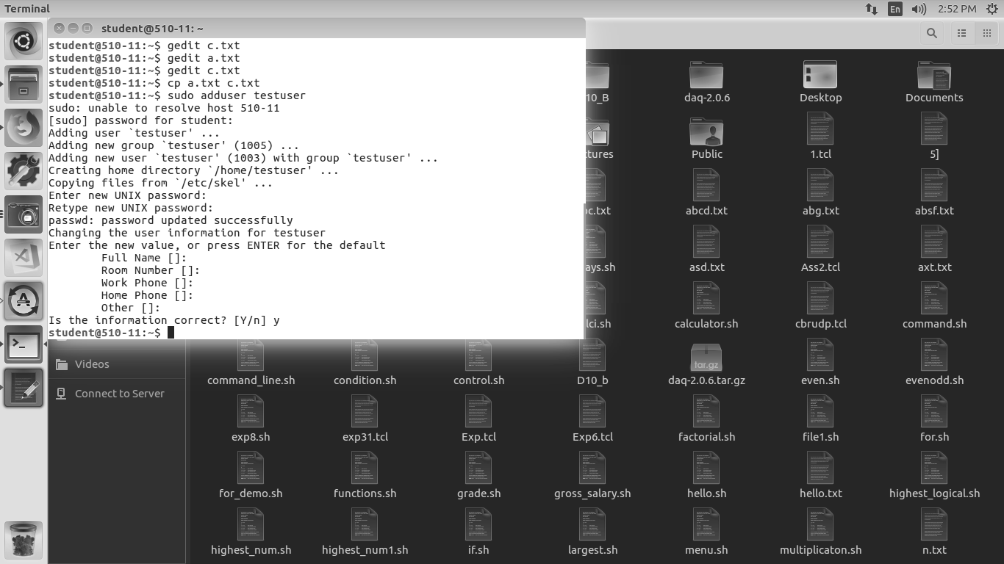

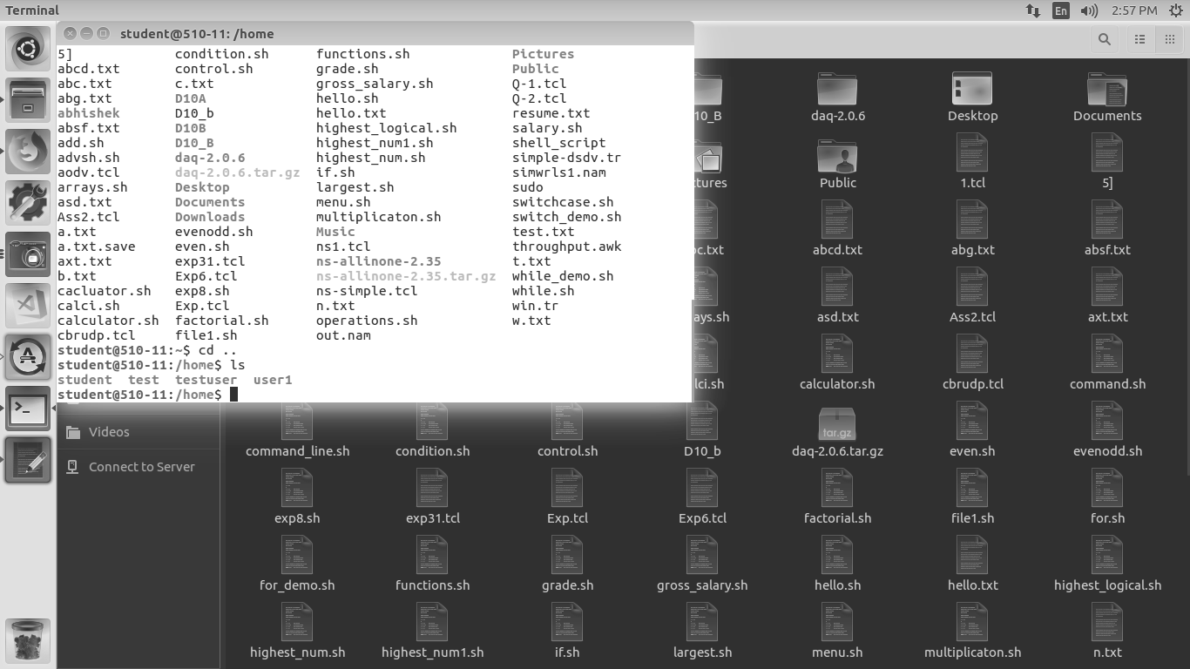

To set the password for the newly created username

If the password is already set, you can change the password using the following syntax.

**Syntax**

passwd <username>

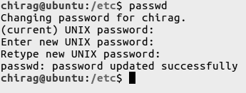

**Group-management**

There are two types of groups in Linux, they are

1. Primary group

2. Secondary or Supplementary group

**Primary group**

To add a user to a Primary group, use the following user mod command as root,

**Syntax**

usermod -g [groupname] [username]

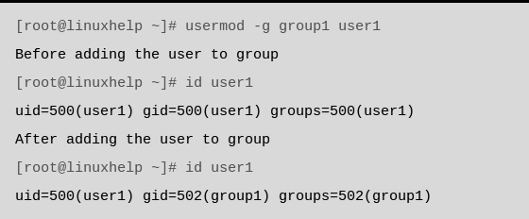

**Secondary Group**

A user can be added to a secondary group using the following command.

**Syntax**

usermod -G [groupname] [username]

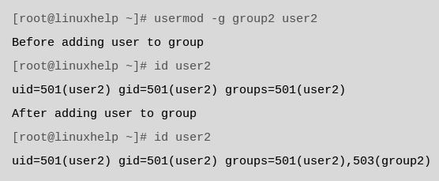

**Adding a group**

To add a group, run the following User management command

**Syntax**

groupadd [groupname]



**Deleting a group**

To delete a group, use the following User management command

**Syntax**

groupdel [groupname]

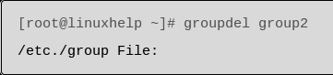

**Memory Management Commands**

**$fdisk**

The fdisk command is a text-based utility for viewing and managing hard disk partitions on Linux. It’s one of the most powerful tools you can use to manage partitions, but it’s confusing to new users.

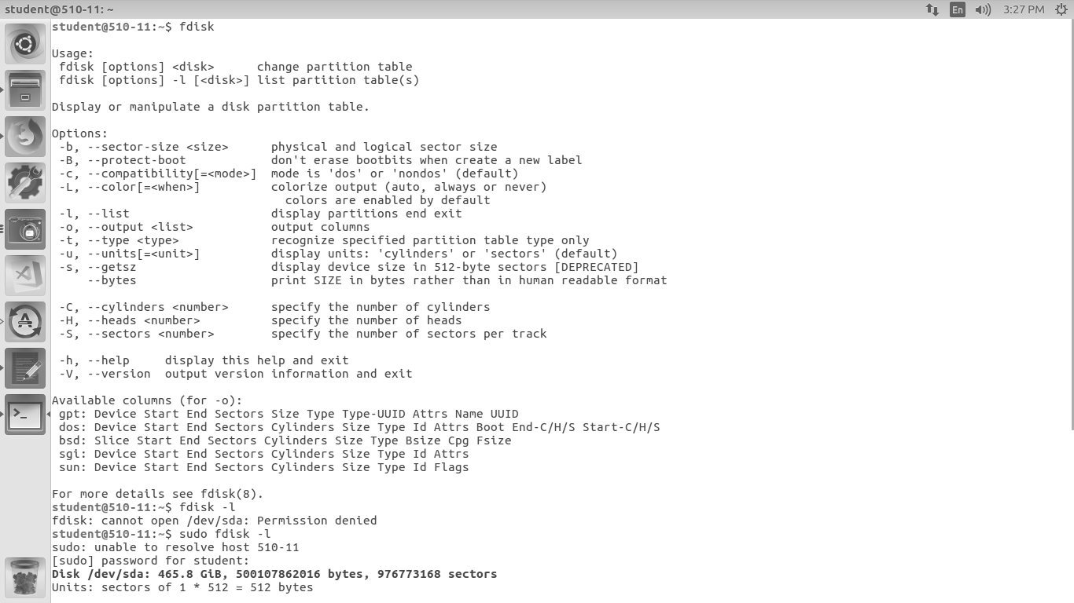

**$fdisk -l :** The fdisk -l commands lists the partitions on your system.

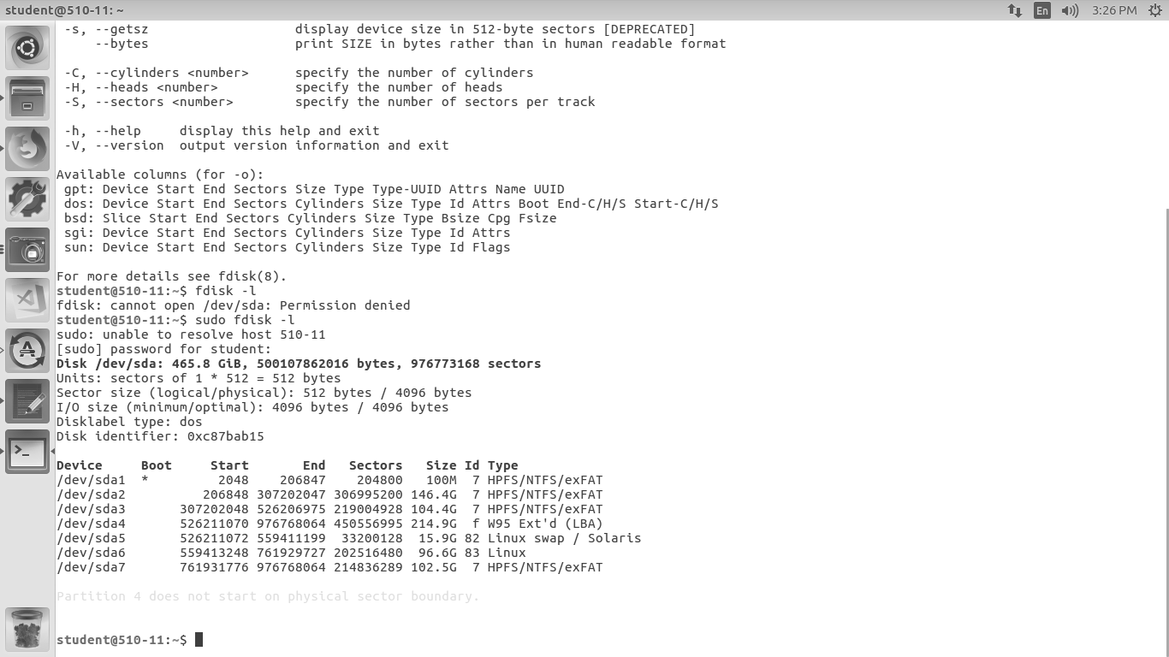

**$mount :** All files accessible in a Unix system are arranged in one big tree, the

file hierarchy, rooted at **/**. These files can be spread out over

several devices. The mount command serves to attach the filesystem found on some device to the big file tree

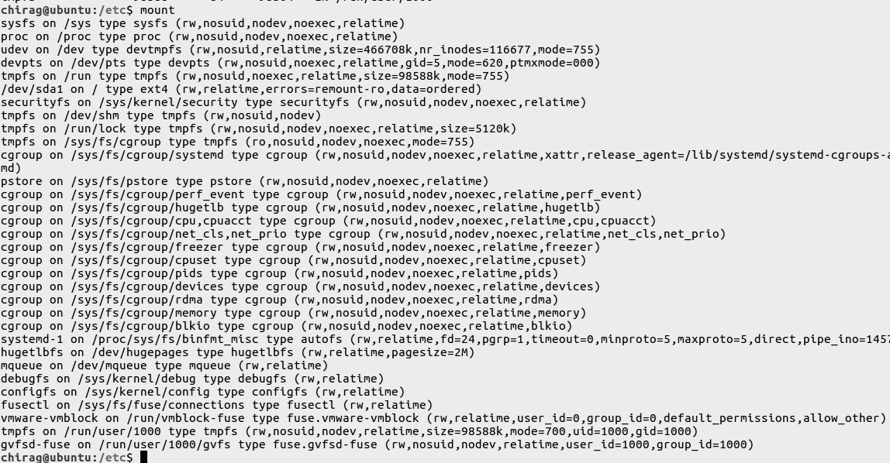

**$du :** The command **du** summarizes disk usage of each FILE, recursively for directories

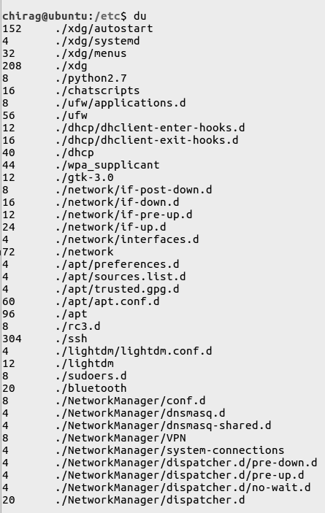



**$df : df** reports file system disk space usage. That is, it displays the total size, the used and available space for each of your mounted partitions.

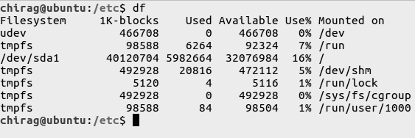

**Conclusion:** These are the most commonly used User and Memory Management commands used in UNIX.